A000-Am,C-Cemi-Shamanic Transformation into Bird Spirit-Serpentine-1000 CE

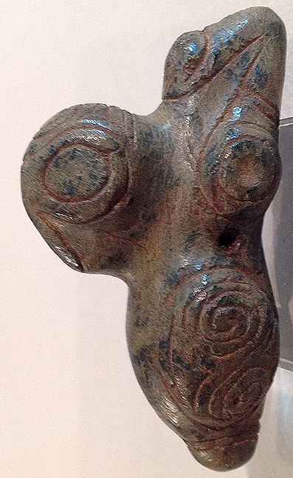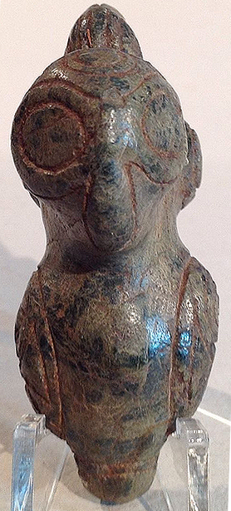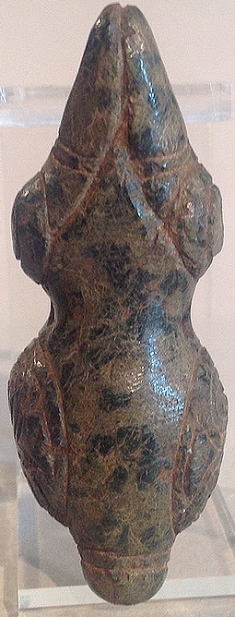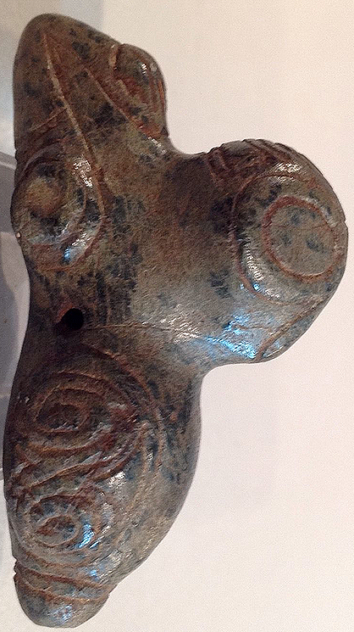

**Case No.: 18**

**Accession No.**

**Formal Label:**

**Display Description:**

A very fine example of the Taino lapidary excellence. This pendant represents a shaman transformation from human to bird. Extended arms become a secondary bird-like head. Wings are interlocking bird head wind or hurricane symbols making this a feminine deity representation. Beautifully conceived in green serpentine with blackish spots.

**LC Classification:**

**Date or Time Horizon:**

**Geographical Area:** Originally from the Dominican Republic

**Map:**

**GPS coordinates:**

**Cultural Affiliation:**

**Media:**

**Dimensions:** Measures 7.0cm or 2.7".

**Weight:**

**Condition:**

**Provenance:**

**Discussion:**

**References:**